Summary

The artefacts share the same frequencies as that of brain signal, hence, filtering alone is insufficient. The EEG and MEG sensors must be very sensitive as the amplitude of the brain signal get reduce by volume conduction effect. Such high sensitivity implies that the chances of recording non cerebral signals are high. Recorded electrical activity not of cerebral origin is termed as “artefact”. Artefacts can be classified into physiological and non-physiological. Physiological artefacts include muscle activity, eye movements, cardiac pulsation and respiration, whereas non-physiological artefacts include sensors malfunction, alternating current, subject movements.

Blind Source Separation is the most favoured method for artefact removal. ICA is best suited for the job. The signal is divided into independent components ICs. Since the brain ICs and artefact ICs closely resemble, classification often involves human expertise.

**Methods**

**IC Extraction**

ICs from both EEG and MEG are extracted by FASTICA. The FASTICA allows computation of optimal no.of ICs along with unmixing and mixing matrices. The FASTICA is maximization of non gaussianity using 4th order cumulant of the signal. Maximization of norm of kurtosis leads to identification of non-Gaussian sources.

**Dataset**

EEG dataset is collected in their facilities with 128 channel EEG system. A total of 1067 ICs are obtained for EEG dataset. MEG dataset comprises of two datasets. First dataset is obtained in their facility and second is open source human connectome dataset[1].

**Procedure**

In order to develop algorithm independent of recording lengths, the CNNs are applied to the ICs spectrum and its weights topographic distributions. In order to ensure balance among the classes EEG and MEG samples are randomly down-sampled.

**ICSPECT and ICMAPS**

ICSPECT is generated which is FFT applied on ICs at sampling rate of 250Hz sampled at 2048 points.

IC weights are organised in a topographic fashion by warping onto a unitary circle. Topographic images (ICMAPs) are generated by interpolation of IC weights at warped location in 51X51 matrices.

The ICMAPs and ICSPECT are Z – Normalised and Min-Max Normalized. Thus, the inputs to the CNN comprises of both ICMAPs and ICSPECT.

**Class Imbalance**

Class imbalance can make the model prefer one class over the other. In order to avoid this bias, we randomly down-sample EEG and MEG signals.

**Architecture**

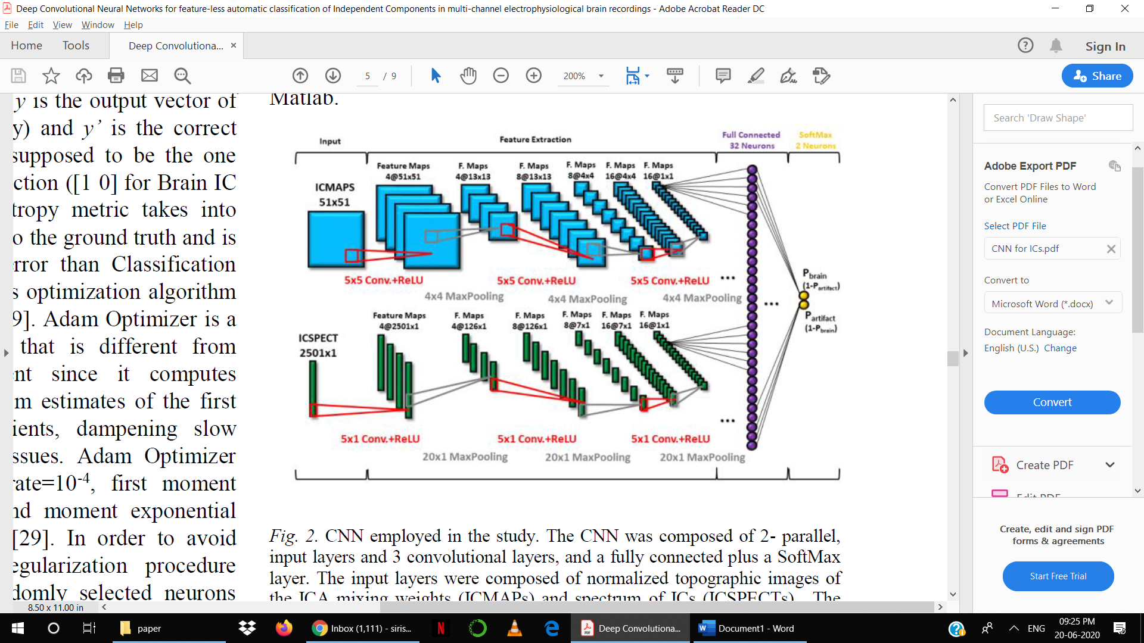

Hyperparameters of the CNN architecture:

* ICSPECT size - 2501 X 1 X 1
* ICMAPs size- 51 X 51 X 1
* No. of filters - 4, 8, 16 respectively
* Filter size - for ICMAPs 5 X 5 , for ICSPECT 5 X 1
* Output of CNN is passed thru ReLU
* Maxpooling size – for ICMAP – 4 X 4, for ICSPECT – 11 X 1
* Random Initialisation of weights – N(0,0.1)
* Cross Entropy loss
* Adam optimizer with lr = 1e-4, 1st exponential decay = 9e-1, 2nd at 9.99e-1, constant = 1e-8
* Trained with batch size = 20 for 200 epochs with 10-fold CV.

**Results**

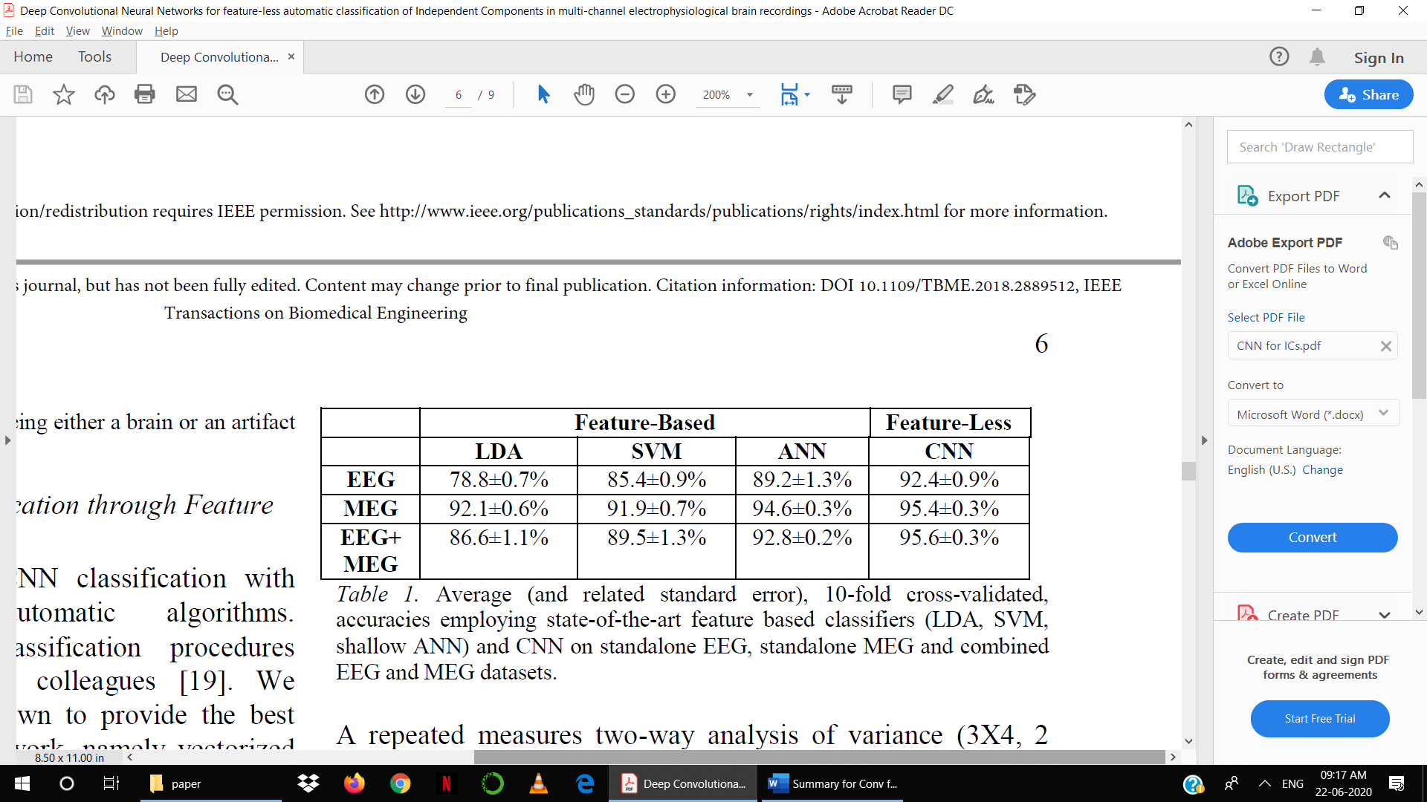

1. L. J. Larson-Prior et al., «Adding dynamics to the Human Connectome Project with MEG», NeuroImage, vol. 80, pagg. 190–201, ott. 2013.